# | PART NAME |  | QTY | PART# | PRICE
1 | LAIRD PLASTICS |  | 1 | PO569611201 | $134.40
2 | ENGINIA HANDLE WITH LOCK |  | 1 | HVC-170-L01 | $9.08 EA
3 | EVERBILT 6.50” BLACK DOOR PULL |  | 2 | 203339987 | $3.14 EA
4 | 5’X10’ 16GA ALUM DIAMOND BRITE |  | 2 | PLFPALTB164896 | $127.98
5 | ¼ X 1” EVERBILT BOLTS (100PK) |  | 16 | 504513 | $13.50
6 | EVERBILT 5” POLYCASTER WITH BRAKE |  | 4 | 203672257 | $13.88 EA
7 | BLUELIT WITH VELCRO |  | 1 | #020145 | $70.00 EA
8 | CLEAR TOP |  | 1 | #020145 | $300.00
9 | 10FT BLACK HIGH DENSITY FOAM |  | 1 | 226270 | $3.82
10 | ENGINIA HANDLE NO LOCK |  | 1 | HVC-170-L01 | $10.16
11 | 6’ FIBERGLASS LADDER |  | 1 | 245T7406 | $187.00
12 | 12” STAINLESS STEEL DOOR HINGE |  | 3 | ICAK9 | $10.78
13 | RUBBER DOOR SEAL (25FT) |  | 2 | 3062B3X1 | $36.75
14 | ENGINIA INSIDE SECURITY HANDLE |  | 2 | HVC-170-ML1 | $2.63 EA
15 | BELL 1 GANG WEATHERPROOF GRAY |  | 1 | 202056213 | $3.45
16 | MASTERCRAFT 259748 P471 OHVAF |  | 1 | 54223 | $499.80
17 | 125-VOLT DUPLEX TAMPER GFCI(20AMP) |  | 1 | 205999867 | $19.97

CALL

Weqffer

CES (407) 682-1313

FOR SERVICES

LAIRD PLASTICS |  | Laird Plastics | PO569611201 | 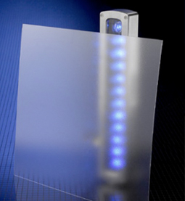
ENGINIA HANDLE WITH LOCK |  | Austin Hardware | HVC-170-L04 | 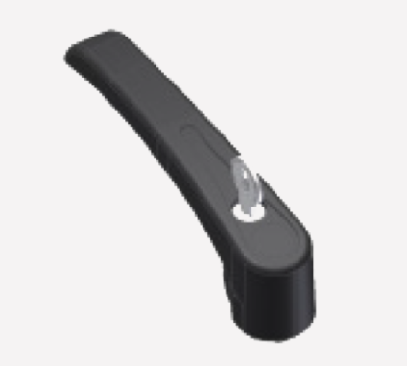
 | EVERBILT 6.50” BLACK DOOR PULL | Home Depot | 203339987 | 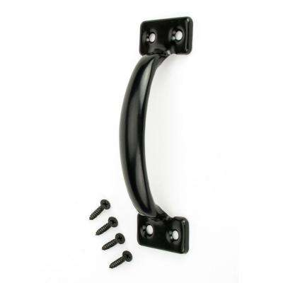
 | 5’X10’ 16GA ALUM DIAMOND BRITE | Surplus Steel & Supply | PLFPALTB164896 | 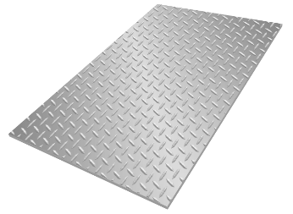

¼ X 1” EVERBILT BOLTS (100PK) | Home Depot | 504513 | 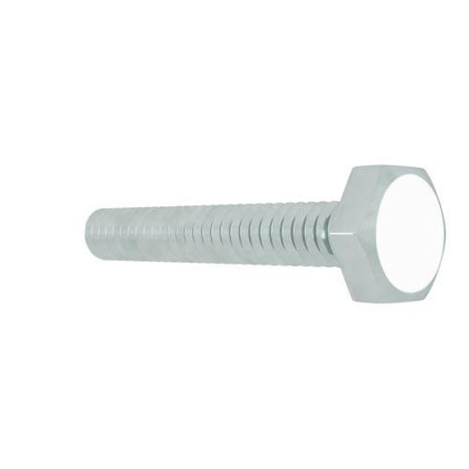
EVERBILT 5” POLYCASTER WITH BRAKE | Home Depot | 203672257 | 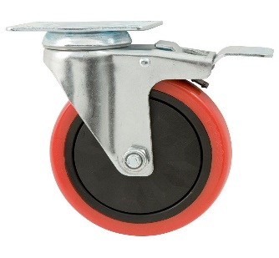
BLUELIT WITH VELCRO | Clean Work Booth | #020145 | 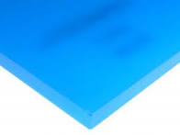
CLEAR TOP | Clean Work Booth | #020145 | 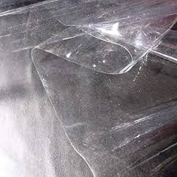
10FT BLACK HIGH DENSITY FOAM | Home Depot | 226270 | 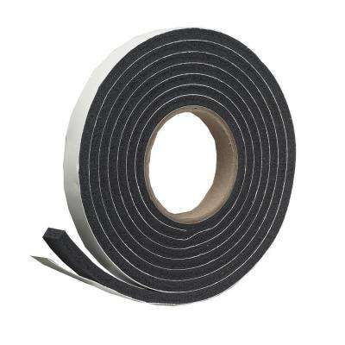
ENGINIA HANDLE NO LOCK | Austin Hardware | HVC-170-L01 | 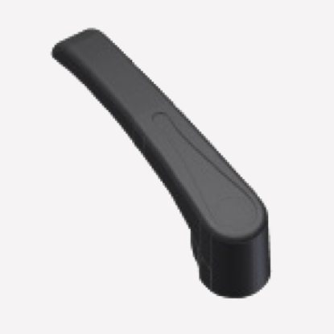
6’ FIBERGLASS LADDER | HD Supply | 245T7406 | 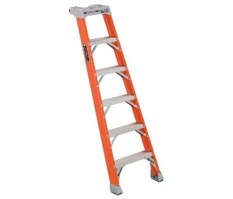
12” STAINLESS STEEL DOOR HINGE | Home Depot | ICAK9 | 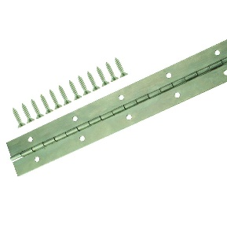
RUBBER DOOR SEAL (25FT) | Home Depot | 3062B3X1 | 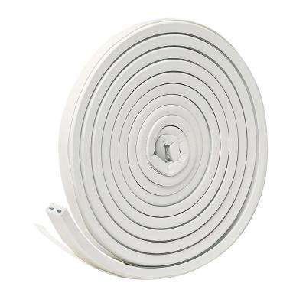
ENGINIA INSIDE SECURITY HANDLE | Austin Hardware | HVC-170-ML1 | 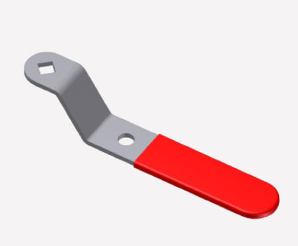
BELL 1 GANG WEATHERPROOF GRAY | 1 | HVC-170-ML1 | 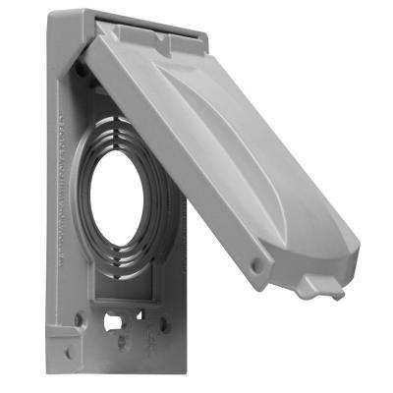
MASTERCRAFT 259748 P471 OHVAF | 1 | 54223 | 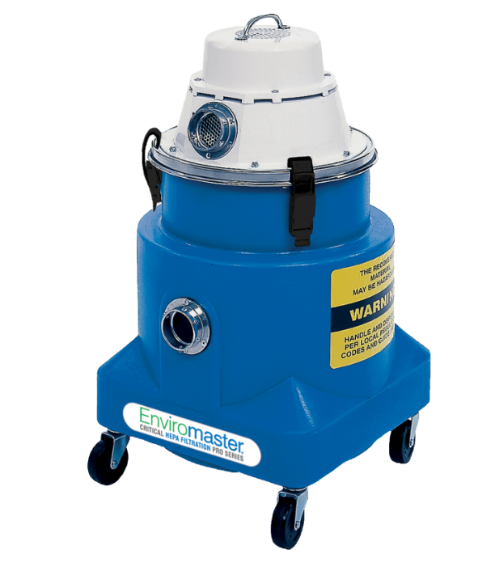
125-VOLT DUPLEX TAMPER GFCI(20AMP) | 1 | 205999867 | 